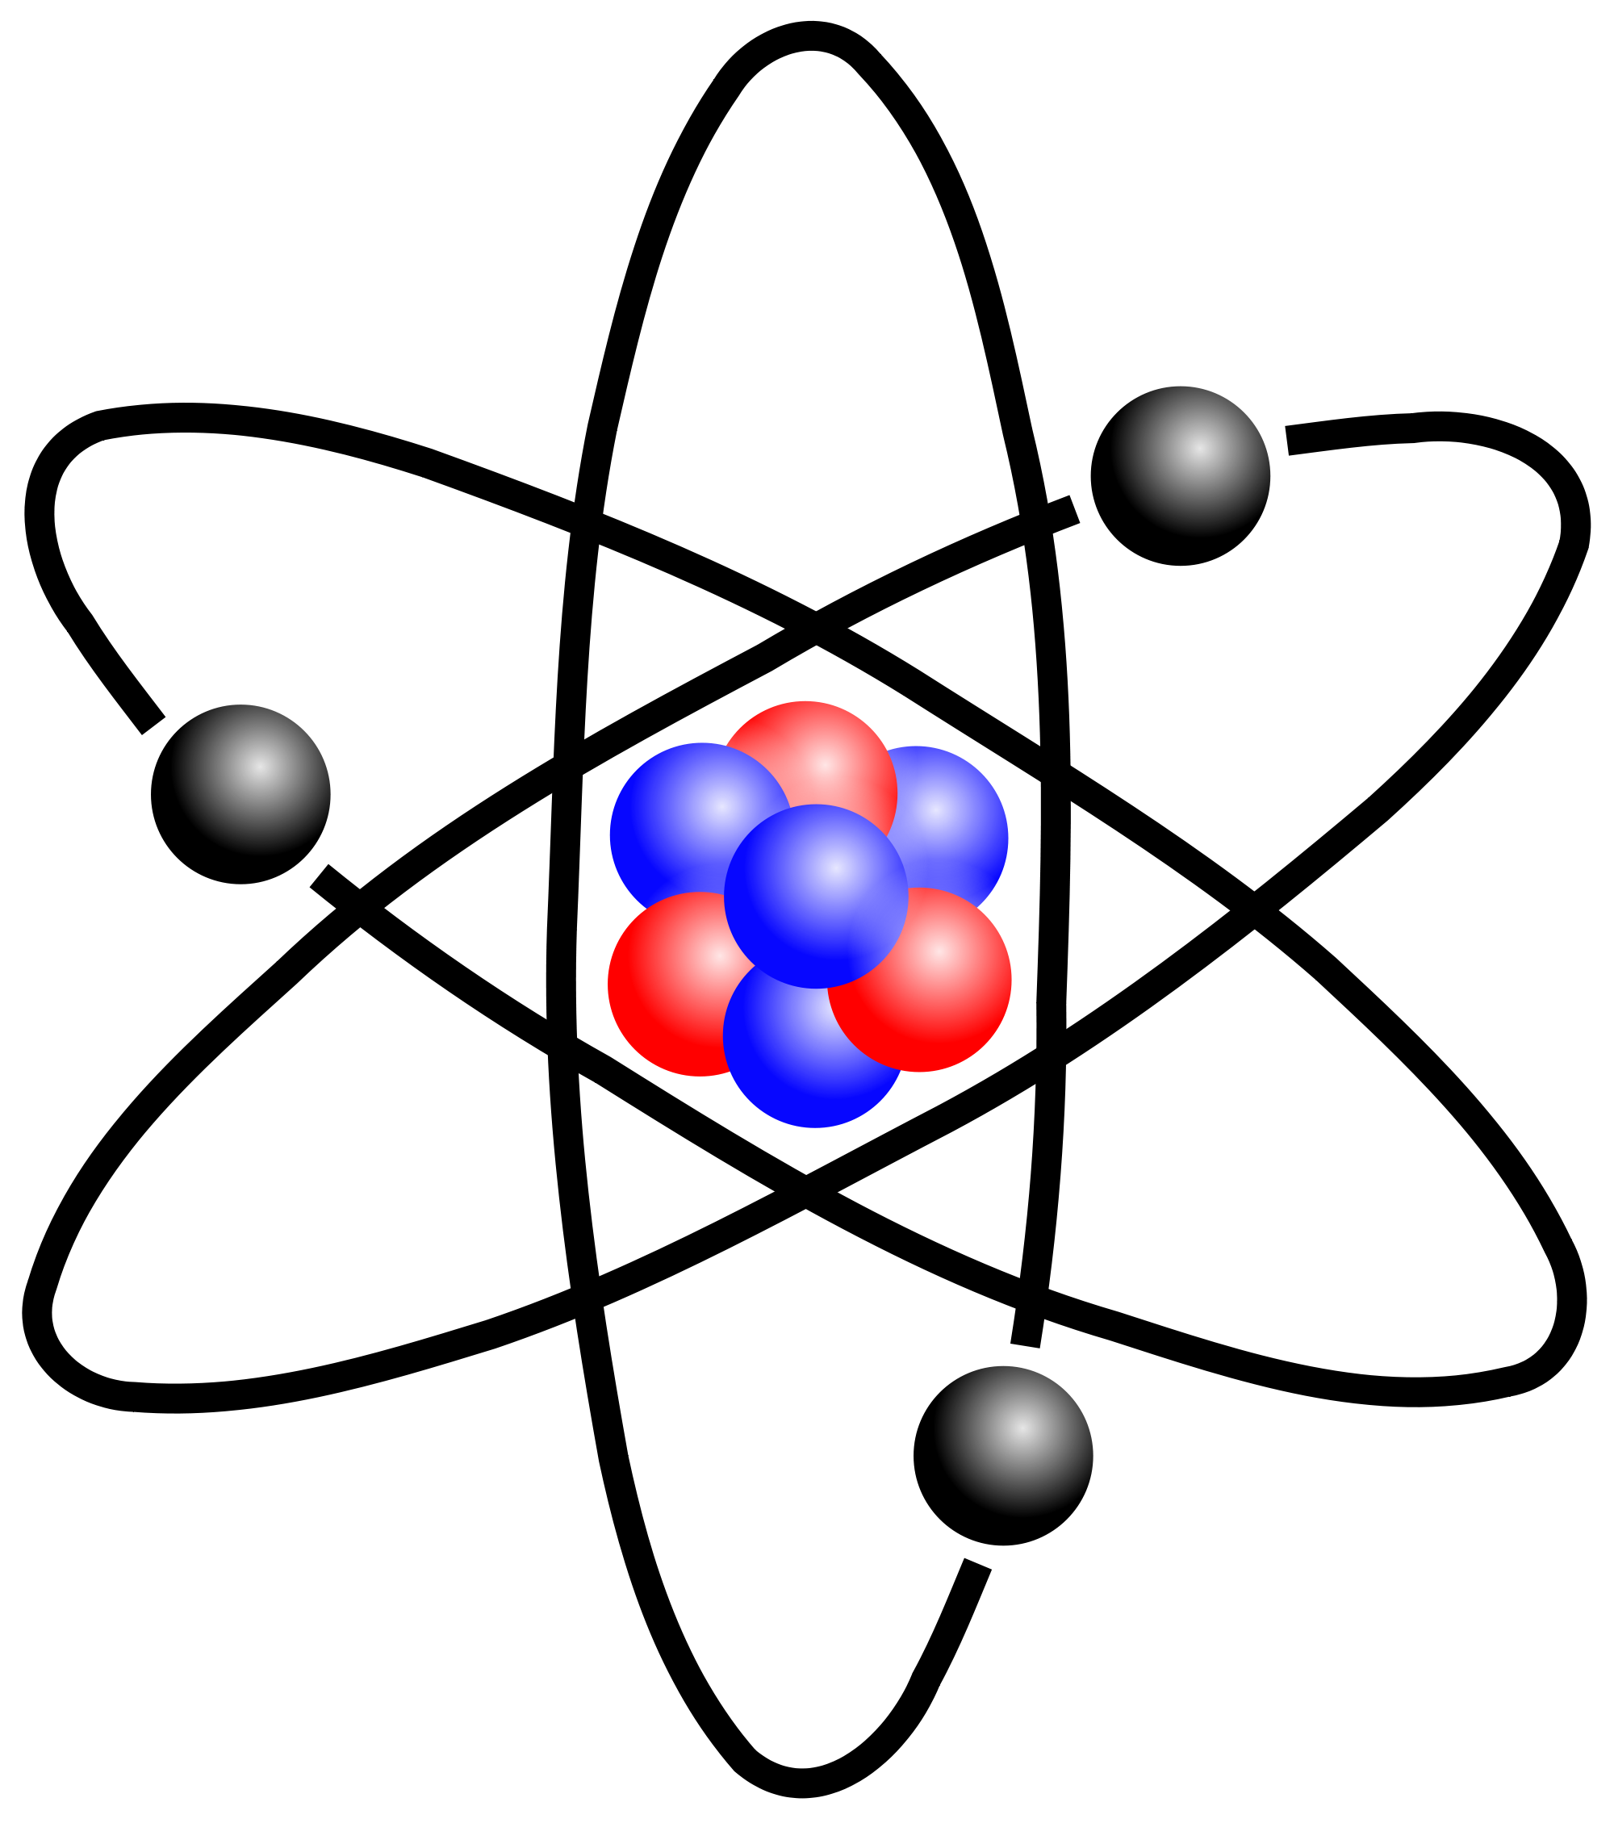
Apostrophe of Possession
Atoms

Apostrophe of possession is used to show that the object belongs to someone or something. For example: Tom’s bicycle. The bicycle belongs to Tom. Or, the house’s roof needed repairing. The roof belongs to the house.

Choose the correct alternative:

1. There are/is only 118 known types/type’s of atoms/atom’s.

2. Every atoms/atom’s characteristics are/is unique.

3. Atoms/atom’s are/is made up of even smaller particles known as subatomic particles/particle’s.

4. Protons/proton’s and neutrons/neutron’s are/is in the nucleus.

5. The protons/proton’s charge are/is positive/negative.

6. The electrons/electron’s are/is in the electron cloud.

7. The electrons/electron’s charge are/is positive/negative.

8. Neutrons/neutron’s have a neutral, or no charge.

9. The number of protons/proton’s in an atom are/is called the atomic number.

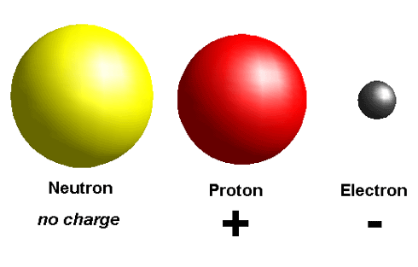
10. The number of protons/proton’s and neutrons/neutron’s in an atom are/is the mass number.

Questions:

1. How many known types of atoms are there? ____________________________

2. Is every atom the same? ____________________________________________

3. What are subatomic atoms? _________________________________________

4. Which subatomic particles are in the nucleus? ___________________________

5. What charge does a proton have? _____________________________________

6. Where do you find electrons? ________________________________________

7. What charge do electrons have? ______________________________________

8. What charge do neutrons have? ______________________________________

9. How do you work out atomic number? ________________________________

10. How do you work out mass number? __________________________________



